Caspase forms double-stranded helical assembly during the type IV Thoeris antiviral response
Linlin Wei^{1,7}, Xian Shu^{2,7}, Wenhe Wang^{3,7,*}, Feixue Li¹, Yue Fan¹, Dong Li¹, Rui Wang², Jingfang Liu⁴, Qian Wang⁴, Lintong Jiang¹, Ludan He¹, Shixuan Duan¹, Lirui Zhao¹, Shouyue Zhang^{2,5}, Jinwei Ren⁶, Yi Zhang¹, Ming Li^{2,5,}*, Yue Feng^{1,}*
¹State Key Laboratory of Green Biomanufacturing, College of Life Science and Technology, Beijing University of Chemical Technology, Beijing, China
²Department of Microbial Physiological & Metabolic Engineering, State Key Laboratory of Microbial Diversity and Innovative Utilization, Institute of Microbiology, Chinese Academy of Sciences, Beijing, China
³Department of Biological Science and Engineering, School of Chemistry and Biological Engineering, University of Science and Technology Beijing, Beijing, China
⁴Institutional Center for Shared Technologies and Facilities of Institute of Microbiology, Chinese Academy of Sciences, Beijing, China
⁵College of Life Science, University of Chinese Academy of Sciences, Beijing, China.
⁶State Key Laboratory of Mycology, Institute of Microbiology, Chinese Academy of Sciences, Beijing, China
⁷These authors contributed equally
*Correspondence: fengyue@mail.buct.edu.cn (Y. F.); lim_im@im.ac.cn (M. L.); wenhewang@hotmail.com (W.W.)

Supplementary Information includes Supplementary Figures 1–12.

Supplementary Figures
Supplementary Fig. S1. The evolutionary tree of type IV Thoeris systems.
(a) Phylogenetic tree showing the distribution of type Thoeris systems among a variety of bacteria and archaea, divided by phyla (color-coded), with human caspase-3 included as an outgroup. Variants experimentally characterized in this work and a recent study by Rousset et al²² are indicated.
(b) Genomic contexts of three type IV Thoeris (AeThoeris, NeThoeris, and Ec587Thoeris). Genes related to CRISPR function (cas) or phage life cycle are shaded in light orange or light blue, respectively. Light brown and white colors indicate other genes with or without predicted conserved domains, respectively. Each CRISPR-like RNA (crlRNA) gene imperfectly matches to its target site within the promoter of Thoeris genes and directs Cas proteins to inhibit their transcription.
(c and d) Growth curve of EP02SG-infected or uninfected E. coli cells that contained a plasmid encoding AeThoeris (C), Ec587Thoeris (D) or the empty vector. Two multiplicities of infection (MOIs, 0.03 and 10) were selected. Error bars (mean ± SD (n = 3)) are colored according to different experimental settings.

Supplementary Fig. S2. Phage major capsid protein (MCP) triggers the Abi-inducing activity of type IV Thoeris.
(a) Transformation efficiency of AeThoeris-encoding E. coli BW25113 cells by plasmids expressing different phage proteins.
(b) Transformation efficiency of E. coli BW25133 cells encoding NeThoeris or EcThoeris by plasmids expressing the MCP of phage EP02SG. CFU, colony forming units. Data are presented as mean ± SD (n = 3). P values were calculated using a two-sided Student’s t test against the vector control. **** p < 0.0001.

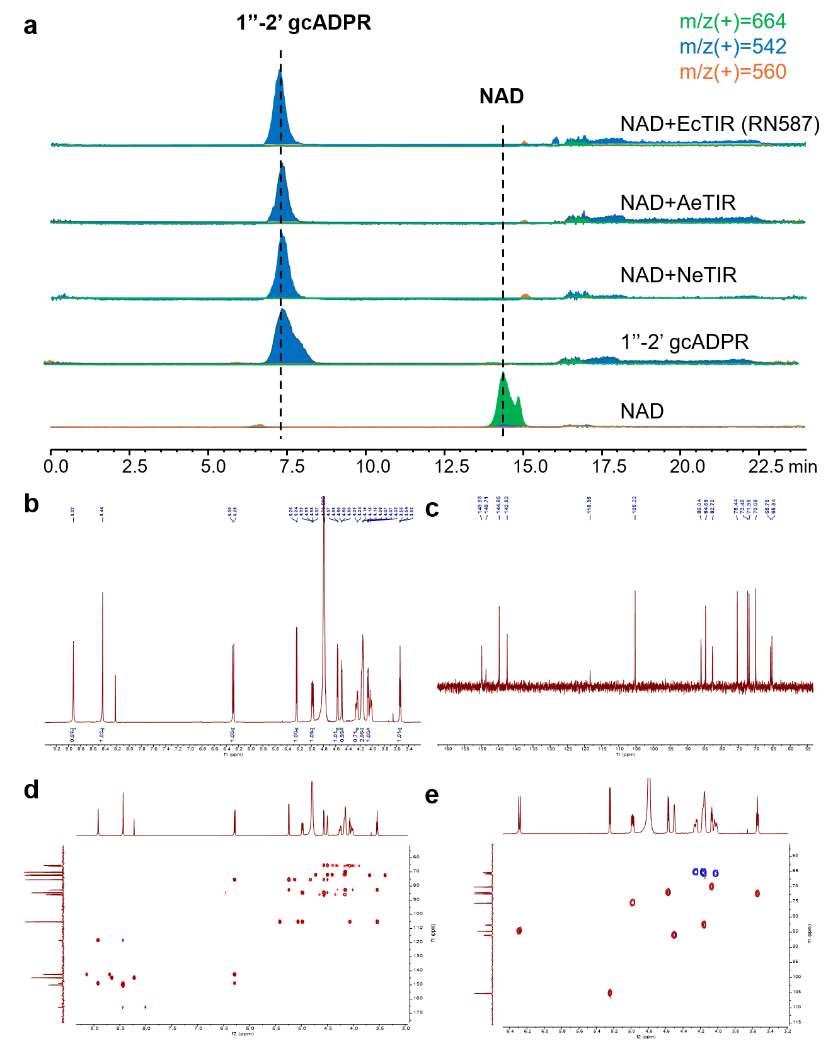
Supplementary Fig. S3 Three TIR proteins convert NAD⁺ to 1′′-2′ gcADPR in vitro, related to Fig. 2
(a) LC-MS analysis of the products of NAD⁺ in vitro treated by NeTIR, AeTIR or EcTIR RN587.
(b) ¹H-NMR of NeTIR-derived 1′′-2′ gcADPR in D₂O (500 MHz).
(c) ¹³C-NMR of NeTIR-derived 1′′-2′ gcADPR in D₂O (125 MHz).
(d) ¹H-¹³C HMBC of NeTIR-derived 1′′-2′ gcADPR.
(e) ¹H-¹³C HSQC of NeTIR-derived 1′′-2′ gcADPR.

Supplementary Fig. S4 N7-cADPR is produced by Type IV Thoeris, related to Figure 2
(a) Assessment of nucleotides associated with NeCaspase after incubation with NeTIR lysate. NeCaspase was incubated with NeTIR lysate, followed by ultrafiltration to remove unbound small molecules. The retained fraction was analyzed by measuring the A260/280 ratio. Data are presented as mean ± SD (n = 3). P values were calculated using a two-sided Student’s t test. *** p < 0.001.
(b) Activation of caspases by molecules released from NeCaspase after protease digestion. After removal of excess small molecules, samples were treated with proteinase K to release bound metabolites, and the resulting filtrates were used to activate NeCaspase and PsCaspase. Fluorescence (FU) was monitored over time (minutes) using a fluorogenic peptide substrate.
(c) MS/MS fragmentation patterns of the authentic standards N7-cADPR and 2′-cADPR. Major diagnostic fragment ions are annotated.
(d) Extracted ion chromatograms (EICs) of the diagnostic fragment ions (m/z 272.941, 211.003, and 78.847) for N7-cADPR (top), 2′-cADPR (middle), and the metabolite released from NeCaspase following proteinase K digestion (bottom). The NeCaspase-released metabolite exhibits identical retention time (0.79 min) and fragment-ion profiles to N7-cADPR but differs from 2′-cADPR (0.84 min), indicating that the released product corresponds to N7-cADPR.

Supplementary Fig. S5 Type IV Thoeris caspase is activated by N7-cADPR, related to Figure 2
(a) PsCaspase activity in response to different cyclic nucleotides. Reactions were supplemented with 2 µM of the indicated nucleotides and fluorescence (FU) was monitored over time.
(b-g) HPLC analysis of caspase and cyclic nucleotide mixtures. Reactions contained 50 µM protein and 25 µM small-molecule ligands, and chromatograms show elution profiles of N7-cADPR and other nucleotides incubated with different caspases.
(h) HPLC analysis of NeCaspase and its CTD with N7-cADPR. Reactions contained 50 µM protein and 25 µM N7-cADPR.
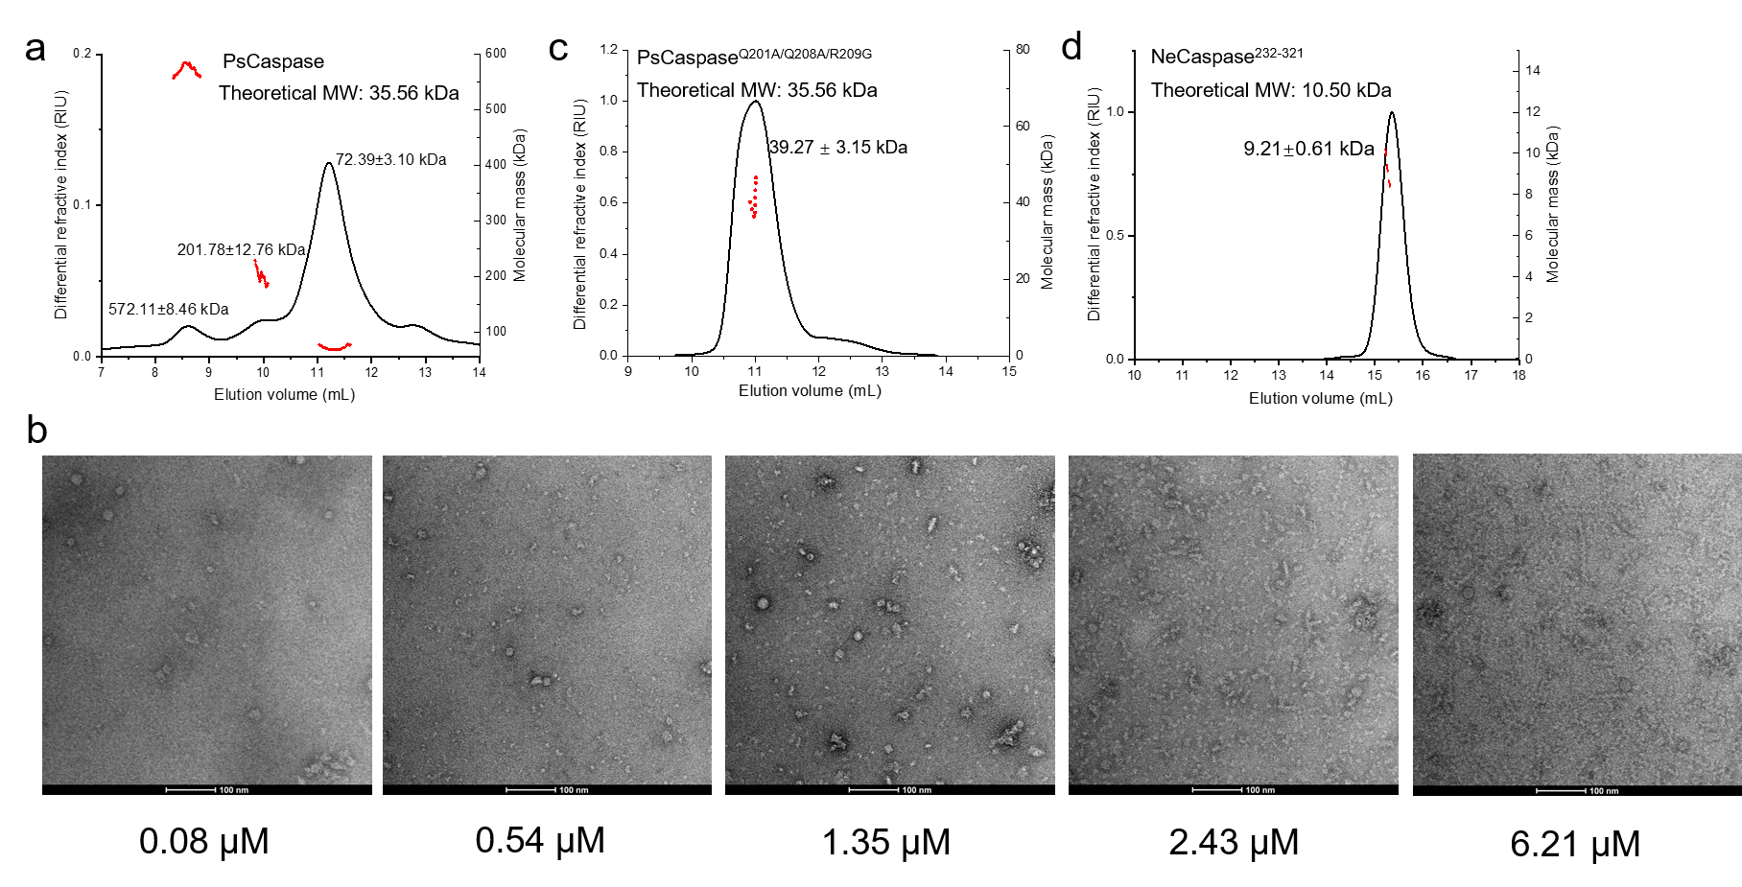
Supplementary Fig. S6 Oligomeric states of Thoeris caspases
(a, c, d) Static light scattering (SLS) analysis of PsCaspase, its mutant and NeCaspase CTD truncation. The measured molecular masses (72.39 ± 3.10 kDa for PsCaspase; 39.27 ± 3.15 kDa for PsCaspase Q201A/Q208A/R209G; and 9.21 ± 0.61 kDa for NeCaspase^{232–321}) are shown relative to the theoretical monomer molecular weights. The NeCaspase CTD truncation harbors residues 232-321.
(b) Negative-stain electron microscopy images of purified PsCaspase under different concentrations. Scale bars, 100 nm.

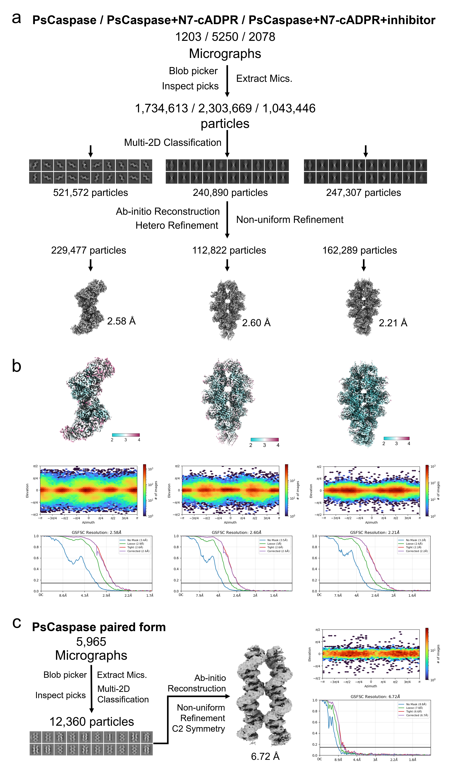
Supplementary Fig. S7 Data processing of cryo-EM datasets.
(a) Schematic representation of the data processing workflow for PsCaspase in the apo form, PsCaspase in complex with N7-cADPR, and PsCaspase in complex with N7-cADPR and inhibitor.
(b) Local resolution maps, angular distributions of particles contributing to the final reconstructions, and gold-standard Fourier shell correlation (FSC) curves from the 3D refinement of PsCaspase in the three respective states.
(c) Schematic representation of the data processing workflow, angular distributions of particles contributing to the final reconstructions, and gold-standard Fourier shell correlation (FSC) curves from the 3D refinement for PsCaspase in the apo paired form.

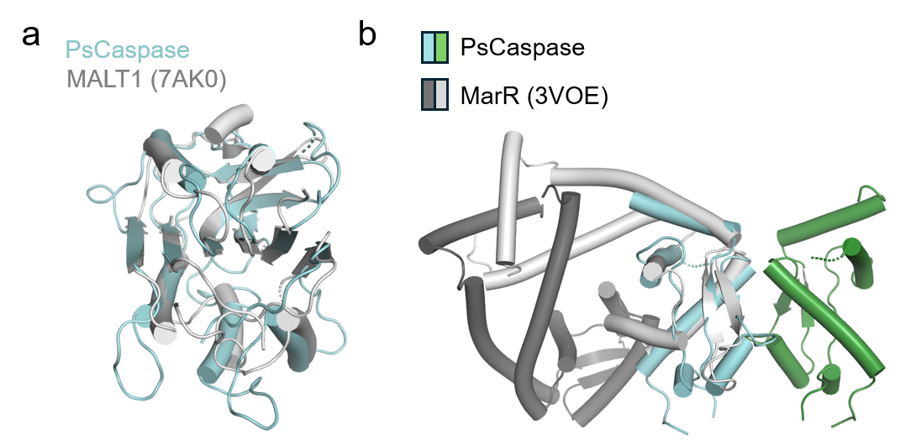
Supplementary Fig. S8 Structural comparison of NTD and CTD of PsCaspase
(a-b) Structural alignment between PsCaspase NTD and MALT1 (PDB code: 7AK0), and between PsCaspase CTD dimer and MarR (PDB code: 3VOE).

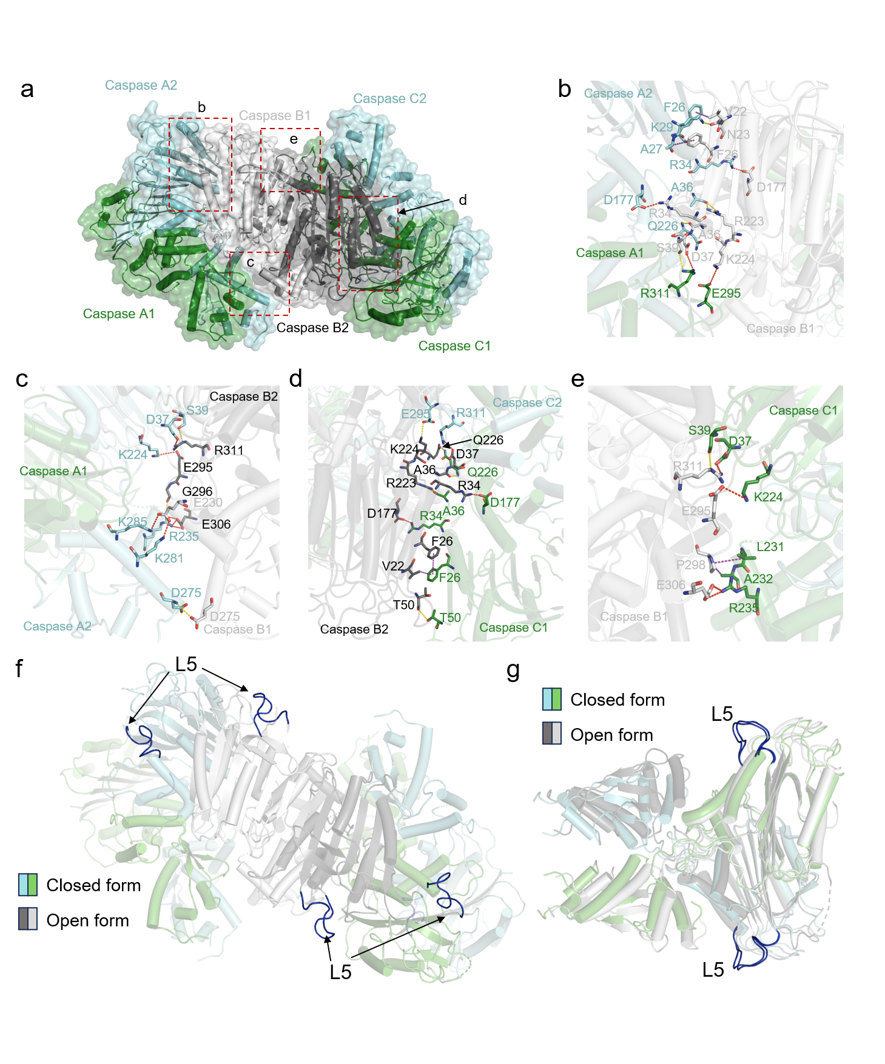
Supplementary Fig. S9 Interface within the apo PsCaspase oligomer
(a-e) Atomic model of the apo PsCaspase oligomer showing three interacting dimers (a), with detailed interactions shown (b-e). Hydrogen bonds, non-covalent π interactions, electrostatic interactions are shown as yellow, purple and red dashed lines, respectively.
(f) The same model as in A highlighting the L5 loop.
(g) Structural alignment of open and closed form of apo PsCaspase dimer highlighting the L5 loop.
Supplementary Fig. S10 N7-cADPR-induced filament formation
(a) Negative-stain EM image of lysates of E. coli expressing the type IV Thoeris system from Pseudomonas sp. 1-7 with or without T6 infection. The scale bars are 5 μm and 100 nm, respectively.
(b) Activity assay of the lysates of E. coli cells expressing different plasmids. Fluorescent caspase activity assays were carried out in a 100 µL reaction mixture containing 25 mM Tris-HCl (pH 7.4), 100 mM NaCl and 1 mM DTT. Each reaction contained 20 µM AMC-IVINQR substrate and 2 µL cell lysate. “+T6” indicates the lysate of cells infected by T6 phage before sonication.
(c) Time-dependent incubation of apo-PsCaspase with N7-cADPR in vitro. Purified 0.68 μM apo-PsCaspase was incubated with 3.4 μM N7-cADPR over time. The incubation time is shown under the image of negative staining EM, respectively. The scale bars are 100 nm.

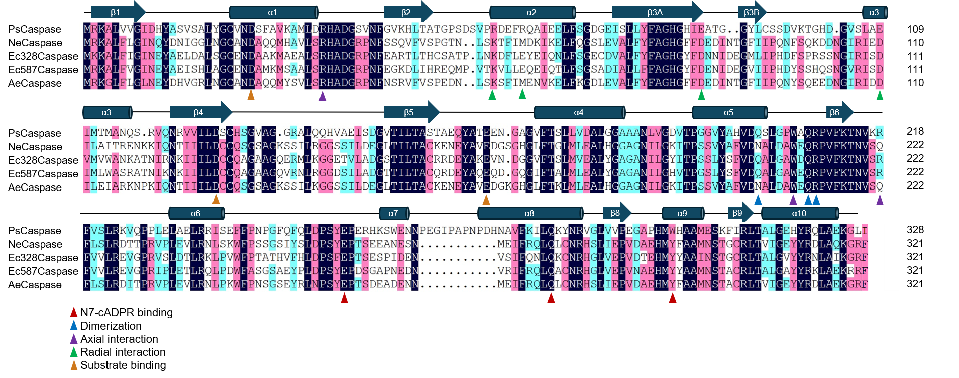
Supplementary Fig. S11 Sequence alignment of Thoeris caspase family members
Residues with 100%, over 80% and over 60% identity are shaded in dark blue, pink and cyan, respectively. Secondary structural elements of PsCaspase are shown above the sequences. Residues involved in N7-cADPR binding are marked with red circles. Residues involved in N7-cADPR binding, dimerization, axial interaction, radial interaction and substrate binding are marked with triangles colored as shown in the legend below the alignment.

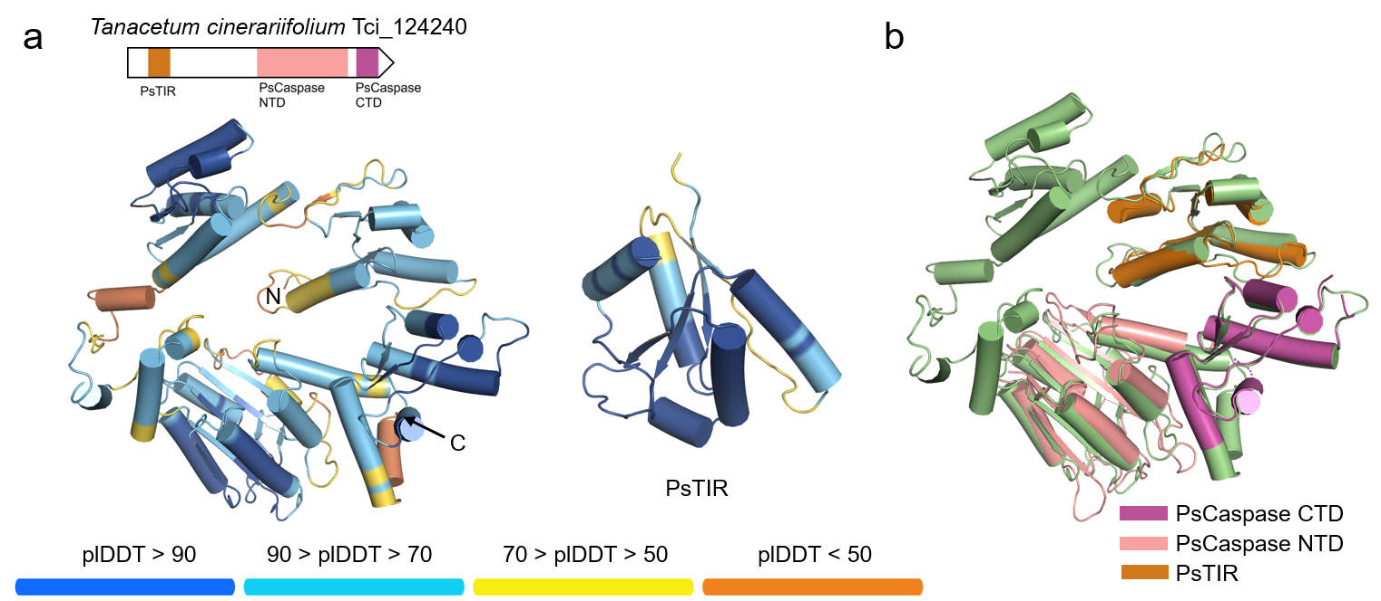
Supplementary Fig. S12 Similarity between a plant protein and the IV Thoeris system
(a) Domain organization and predicted structure of a plant caspase-like protease fused with TIR and PsCaspase CTD-like domain. Predicted structure of PsTIR. The predicted structures are colored by plDDT.
(b) Structure superimposition between Tci_124240 and NTD, CTD of PsCaspase and predicted structure of PsTIR.

